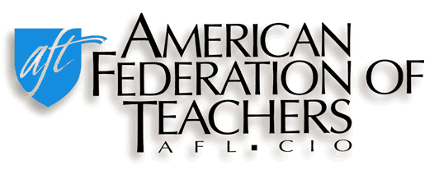
LOCAL 1796
WILLIAM PATERSON UNIVERSITY
GRANT HALL - ROOM 233
300 POMPTON ROAD, WAYNE NJ 07470-2103
973.720.2988 - FAX: 973.720.2057
Email: AFT-office@wpunj.edu

SUSANNA TARDI, Ph.D., PRESIDENT

TO: ALL FULL, PART-TIME & ADJUNCT FACULTY, PROFESSIONAL STAFF, AND LIBRARIANS
FROM: AFT LOCAL 1796 EXECUTIVE BOARD
DATE: MARCH 30, 2023
RE: UNION SCHOLARSHIPS

*KINDLY ANNOUNCE THE FOLLOWING TO YOUR STUDENTS*

AFT OFFERS SCHOLARSHIPS!

The American Federation of Teachers Local 1796 is pleased to announce that we are awarding three (3) $1000.00 scholarships to WPU students: one (1) Local 1796 Scholarship, one (1) Local 1796 Irwin Nack Scholarship, and one (1) CNJSCL-Council of New Jersey State College Locals Scholarship. The three (3) scholarships will be awarded this year, and will be deposited into student accounts for payment toward tuition and fees for the upcoming 2023-2024 academic year. The criteria needed to be eligible for one of these scholarships are the following: (1) G.P.A. of at least 3.0, (2) membership in a union by the applicant or a member of his/her family, and (3) the submission of an essay (see application). Graduate students are encouraged to apply, as they will be eligible for one of the $1000 scholarships.
Application forms for this year’s Local 1796 scholarships are attached to this email or may be obtained at the AFT Office located in Grant Hall Room 233, The David and Lorraine Cheng Library Reference Desk, the Valley Road Information Desk, or by emailing the Union office at AFT-Office@wpunj.edu to request an application via email. Completed applications must be returned to the AFT Office on or before April 14, 2023. Applications may be left under the door of the Union office, or a scan of the complete application may be sent via email to AFT-Office@wpunj.edu.

*The decision of the Union Scholarship Committee will be final.

AFT LOCAL 1796 SCHOLARSHIP APPLICATION

NAME _______________________ BANNER # 855___________________
ADDRESS _______________________ TELEPHONE _______________________ _ _______________________ EMAIL _______________________

Student Status (Check one)
Full-time ______ Part-time ______, Grade Point Average (At end of Fall 2022 semester): ____________
Anticipated Graduation Date: _______________

Name of Family Member in Union: _____________________________
Relationship to Student: ______________________________________
Name of Union (Attach a photocopy of union card to application):_______________________________

Employment Experience (If available, attach resume): _______________________________________________________________________________________________________________________________________________________________________________________________________________________________________________________________

Please list and describe all University and/or community service contributions. Include the name of the organization, type of activity, time frame and length of service.
____________________________________________________________________________________________________________________________________________________________________________________________________________________________________________________________________________________________________________________________________________________

The following documents must be included with this application form:
- Official transcript
- At least one and no more than three letters of recommendation from a WPUNJ professor, professional staff member or librarian
- A type-written, double-spaced essay with a minimum length of 500 words on “The Importance of Unions in American Society”

SIGNATURE OF STUDENT _____________________________________Date__________

Return completed application by April 14, 2023 to AFT Local 1796, Grant Hall, Room 233 or email scan of complete application, including all required materials, to AFT-office@wpunj.edu.

*Incomplete applications will not be reviewed.

